**VISUALIZATION TOOL FOR ELECTRIC VEHICLE CHARGE**

**AND RANGE ANALYSIS**

1. **INTRODUCTION**

In the search for constant development and innovation, mankind invented a colossal number of vehicles,and these inventions went through many stages of development and adaptation, resulting in one of the most important innovations in the 19th century,known as the electric car. In the content of globalisation, large scale economic, political, social and environmental transformations have taken place that have not gone unnoticed for the automotive industry constant changes in resource supply and prices, trade barriers and fuel price fluctuations have put car manufacturing companies in a new reality

Electric vehicles have low running costs as they have less moving parts for maintaining and also very environmentally friendly as they use little or no fossil fuels (petrol or diesel). While some EVs used lead acid or nickel metal hydride batteries, the standard for modern battery electric vehicles is now considered to be lithium ion batteries as they have a greater longevity and are excellent at retaining energy, with a self discharge rate of just 5% per month. Despite this improved efficiency, there are still challenges with these batteries as they can experience thermal runaway, which have, for example, caused fires or explosions in the Tesla model S, although efforts have been made to improve the safety of these batteries.

**1.1 OVERVIEW**

Battery electric car are all electric and don't use gasoline, and instead have a large battery that powers one or more electric motors. Currently battery _ electrics have a driving range of 80 to more than 300 miles,with ranges increasing as new models are introduced.In addition to driving past the gas station, battery electrics don't require much maintenance compared to gas cars. Charging a battery_ electric car can be done at home using standard 120_ volt or 240 volt house plugs, or away from home at public or workplace charging stations _ one benefit of battery_ electric cars over plug_ hybrids is the capability to use DC fast chargers, which provide more than 100 miles of range in 30 minutes. An electric car, battery electric car, or all-electric car is an automobile that is propelled by one or more electric motors, using only energy stored in batteries. Compared to internal combustion engine (ICE) vehicles, electric cars are quieter, have no exhaust emissions, and lower emissions overall.[1] In the United States and the European Union, as of 2020, the total cost of ownership of recent electric vehicles is cheaper than that of equivalent ICE cars, due to lower fueling and maintenance costs.[2][3] Charging an electric car can be done at a variety of charging stations; these charging stations can be installed in both houses and public areas.

**1.2 PURPOSE**

Battery-electric cars don’t use any gasoline, but instead run solely on electricity stored in a battery pack that energizes one or more electric motors and produces zero tailpipe emissions. These cars can be charged most anywhere, anytime and usually at a much lower cost than fueling with gasoline. Their driving ranges on a full charge vary widely from about 100 to more than 500 miles, with considerably higher ranged electric cars coming soon. An electric car battery is an energy accumulator that stores electricity for transmission to an alternating or continuous current engine. However, its importance is far greater than this. The battery is what makes these vehicles sustainable, what releases it from its dependence on fossil fuels. Electric vehicles use electricity to charge their batteries instead of using fossil fuels like petrol or diesel. Electric vehicles are more efficient, and that combined with the electricity cost means that charging an electric vehicle is cheaper than filling petrol or diesel for your travel requirements. All-electric vehicles, also referred to as battery electric vehicles (BEVs), have an electric motor instead of an internal combustion engine. The vehicle uses a large traction battery pack to power the electric motor and must be plugged in to a wall outlet or charging equipment, also called electric vehicle supply equipment (EVSE).

2 .**PROBLEM DEFINITION & DESIGN THINKING**

**2.1 EMPATHY MAP:**

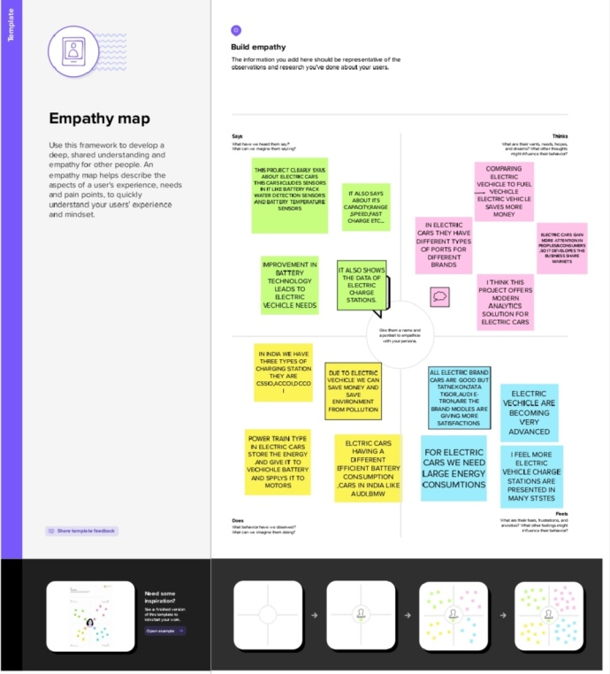

* 1. **IDEATION AND BRAINSTROMING MAP:**

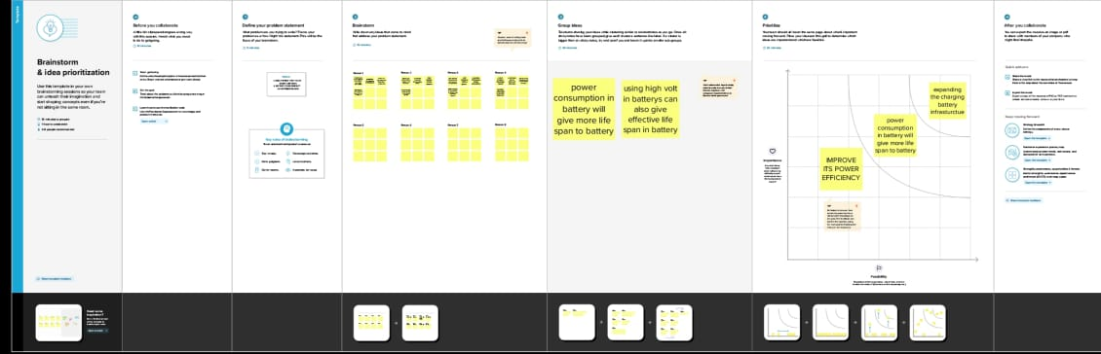

1. **.RESULT:**



First we installed the MySQL to stored the data. In MySQL we register using user name and password after that we entered into the home. Using the root we imported the data into Mysql which we stored the data in excel sheet. After we imported we can see the output data which we see in the above screenshot.



To make the data table first we register in tableau and the we got the link in mail to download the tableau using the link we downloaded after that we connect the tableau server with MySQL after that we connect the sever with sever code and password. next we can see the stored data in tableau the we drag the data and formed the data table.

**4.ADVANTAGES**

No fuel required so you save money on gas.

Environmental friendly as they do not emit pollutants.

Lower maintenance duce to an efficient electric motor.

Better performance.

Electric cars are much quieter much than petrol and diesel vehicles. In fact electric cars are so quiet, they are now required by law to have an Acoustic vehicle alert system to emit a sound when reversing or traveling below 12mph.

Better resale value second hand electric cars could be a great affordable option if you're looking to make the switch from petrol.

**DISADVANTAGES**

Higher purchase cost compared to regular automobiles electric vehicles are highly pricy.

Low speed and range.

Low price on selling.

The inconveniences of service station.

Low energy.

Battery expanse.

Slow charging

Expensive recharging options

Battery issues climate control and in car electronics are among the biggest problem In electric vehicles.

Charging taking longer.

Finding a charging stations are fewer and further between than gas stations.

**5.APPLICATION:**

*Public transportation.

*Renewable energy storage.

*Aviation.

*Electricity Grid.

*Military.

*Wearable technology.

Electricity is the thing. There are no whirring and grinding gears with their numerous levers to confuse. There is not that almost terrifying uncertain throb and whirr of the powerful combustion engine. There is no water-circulating system to get out of order — no dangerous and evil-smelling gasoline and no noise.”

Now, burning coal or natural gas at a generation plant to produce electricity to later power electric cars is clearly not the smartest way to reduce pollution and CO2 emissions—although still better than gasoline vehicles.

distributed solar in rooftops, charging…

clean batteries—hopefully, FlashCharge Batteries—in the basements, that charge…

electric cars at any time of the day or night in 15 minutes or less—hopefully, cars powered by FlashCharge Batteries.

For electric cars to become the vehicle of choice and reduce pollution from fossil fuel combustion, manufacturers’ only need is a battery that: charges fast, powers cars for 100 miles or more, delivers more power for instant response and is non-flammable

**6.CONCLUSION:**

The progress that the electric vehicle industry has seen in recent years is not only extremely welcomed, but highly necessary in light of the increasing global greenhouse gas levels. As demonstrated within the economic, social, and environmental analysis sections of this webpage, the benefits of electric vehicles far surpass the costs. The biggest obstacle to the widespread adoption of electric-powered transportation is cost related, as gasoline and the vehicles that run on it are readily available, convenient, and less costly. As is demonstrated in our timeline, we hope that over the course of the next decade technological advancements and policy changes will help ease the transition from traditional fuel-powered vehicles. Additionally, the realization and success of this industry relies heavily on the global population, and it is our hope that through mass marketing and environmental education programs people will feel incentivized and empowered to drive an electric-powered vehicle. Each person can make a difference, so go electric and help make a difference.

Electric vehicles (EVs) have a battery instead of a gasoline tank, and an electric motor instead of an internal combustion engine. Plug-in hybrid electric vehicles (PHEVs) are a combination of gasoline and electric vehicles, so they have a battery, an electric motor, a gasoline tank, and an internal combustion engine.The progress that the electric vehicle industry has seen in recent years is not only extremely welcomed, but highly necessary in light of the increasing global greenhouse gas levels.

Hybrid cars are definitely more environmentally friendly than internal-combustion vehicles. Batteries are being engineered to have a long life. When the hybrid cars become more widespread, battery recycling will become economically possible. Research into other energy sources such as fuel cells and renewable fuels make the future look brighter for hybrid cars.

**7.FUTURE SCOPE:**

Electric vehicles (EV) is the future not only of transport but of our planet. Can electric vehicles ever face a more serious form of gridlock however.These vehicles are plugged into a charging station at a low voltage. There are no emissions released from these vehicles. The future potential of electric vehicles is enormous. The obvious starting point for these vehicles is thecharging station. This is however only the first step in a potential journey which will see charge Banks and other industrial areas as well as homes and cities. The future scope of electric vehicles is therefore massive. The future scope of electric vehicles is therefore enormous. We have already seen that technology for these vehicles is here and becoming far more advanced. We now know that such vehicles can provide us with great flexibility and we will soon see that potential.

Power source is one of the most important aspects and the global market segmentation is analysed with detailed information. The present day electric vehicles are using different sources such as the wind power, solar power and hydroelectric power. Most of these technologies have evolved in Africa. Some of the countries which have developed these technologies are Morocco, South Africa, Tanzania, Namibia, Zimbabwe and Brazil. It should be noted that these nations all have very low fuel costs and this means that it is very affordable to install a charging system on the cars.

Electric vehicles have enormous future potential. The charging station is the obvious starting point for these vehicles. However, this is only the first step in a potentially long journey that will include charging banks and other industrial areas, as well as homes and cities. Electric vehicle technology has existed in labs such as NASA since the 1970s. In a few years, current technology will undoubtedly be far more advanced. EVs are even expected to power themselves by harvesting energy from their surroundings. Such vehicles will require little maintenance and may even be powered by renewable energy sources such as wind. It will also be interesting to see the impact of EU and US regulations that will go into effect. These regulations are intended to reduce the use of gasoline-powered vehicles. As the popularity of electric vehicles grows, so will the need to reduce their use. It is obvious that new zero-emission technologies will be required

8. APPENDIX: Trailhead link

Team leader: https://trailblazer.me/id/jjayabharathi1

Group member 1: https://trailblazer.me/id/jjayabharathi1

Group member 2: https://trailblazer.me/id/jjayabharathi1

Group member 3: https://trailblazer.me/id/jjayabharathi1